**Installing PHP 7.2 with Apache**

If you are using [Apache](https://linuxize.com/post/how-to-install-apache-on-ubuntu-18-04/) as your web server to install PHP and Apache PHP module run the following command:

sudo apt install php libapache2-mod-php

Once the packages are installed restart the Apache service:  
sudo systemctl restart apache2

## Installing PHP extensions [#](https://linuxize.com/post/how-to-install-php-on-ubuntu-18-04/#installing-php-extensions)

To extend the core functionality of PHP you can install some additional extensions. PHP extensions are available as packages and can be easily installed with:

sudo apt install php-mysql

**Testing PHP Processing**[**#**](https://linuxize.com/post/how-to-install-php-on-ubuntu-18-04/#testing-php-processing)

To test whether your web server is configured properly for PHP processing, create a new file called info.php inside the /var/www/html directory with the following code:

/var/www/html/info.php

<?php

phpinfo();

Copy

Save the file, open your browser of choice and visit http://your_server_ip/info.php

The phpinfo function will print information about your PHP configuration as shown on the image below:

## Requirements for Installing phpMyAdmin on Ubuntu

Before installing phpMyAdmin, we need to meet some basic requirements:

* A LAMP stack (Linux, Apache, MySQL, and PHP) installed
* PHP 5.2.0 or newer

|  |  |
| --- | --- |
| 1  2  3  4  5 | $ php -v  PHP 5.5.9-1ubuntu4.6 (cli) (built: Feb 13 2015 19:17:11)  Copyright (c) 1997-2014 The PHP Group  Zend Engine v2.5.0, Copyright (c) 1998-2014 Zend Technologies      with Zend OPcache v7.0.3, Copyright (c) 1999-2014, by Zend Technologies |

* The PHP mysql or mysqli extensions

|  |  |
| --- | --- |
| 1  2  3 | $ php -m | grep mysql  mysql  mysqli |

* MySQL 5.0.1 or newer

|  |  |
| --- | --- |
| 1  2  3  4 | $ mysql -v  Welcome to the MySQL monitor.  Commands end with ; or g.  Your MySQL connection id is 39  Server version: 5.5.41-0ubuntu0.14.04.1-log (Ubuntu) |

### **Step 1: Update Package Index**

First, we need to make sure our local server is pulling the latest updates.

|  |  |
| --- | --- |
| 1 | sudo apt-get update |

### **Step 2: Install phpMyAdmin Package**

Now we can install the latest version of phpMyAdmin.

|  |  |
| --- | --- |
| 1 | sudo apt-get install -y phpmyadmin |

### **Step 3: Configure phpMyAdmin Package**

After installing phpMyAdmin, you will be presented with the package configuration screen.

Press the SPACE bar to place an **“*”** beside “apache2.”

Press TAB to highlight “OK,” then hit ENTER.

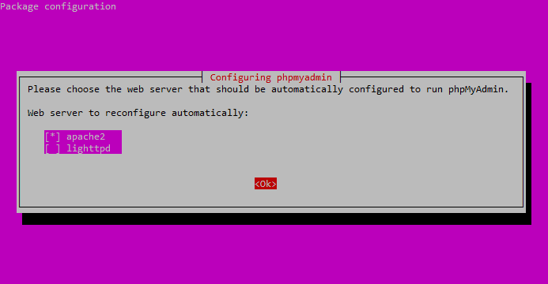

Select “apache2” and hit OK.

The installation process will continue until you’re back at another package configuration screen.

Select “Yes” and then hit ENTER at the dbconfig-common screen:

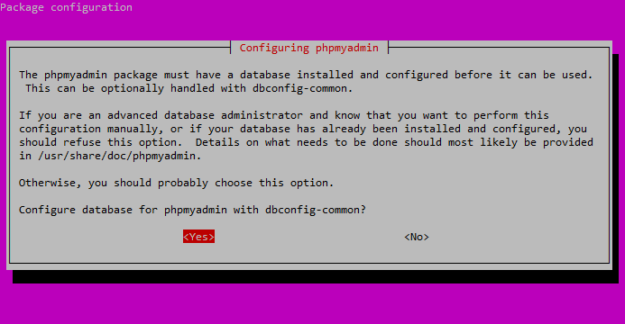

Select “Yes” and hit ENTER.

You will be prompted for your database administrator’s password.

Type it in, hit TAB to highlight “OK,” and then press ENTER.

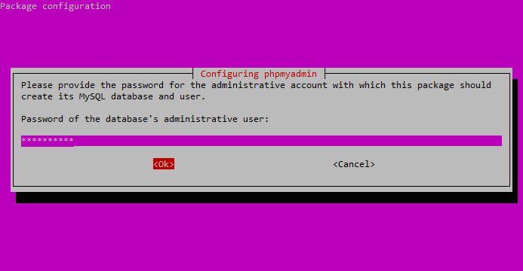

Enter your DB administrator’s password.

Next, enter a password for the phpMyAdmin application itself.

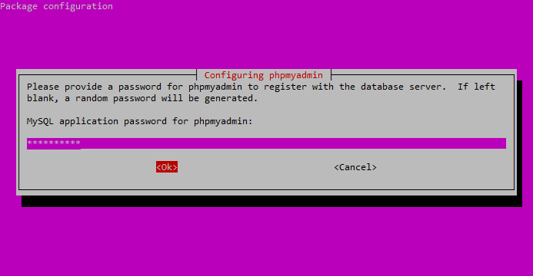

Enter the password you’d like to use to access the phpMyAdmin interface.

Confirm the phpMyAdmin application password.

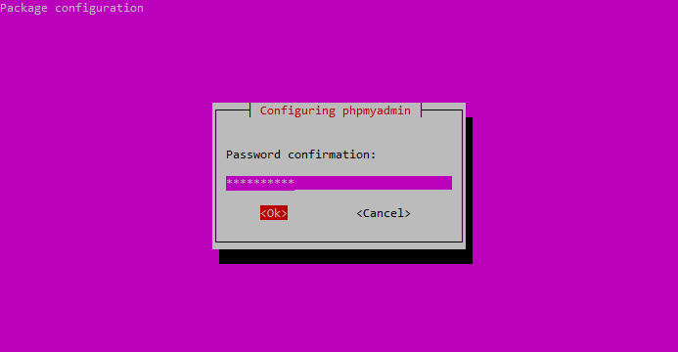

Confirm your phpMyAdmin password.

After the installation process completes, it adds the phpMyAdin configuration file here:

**/etc/apache2/conf-enabled/phpmyadmin.conf**

ManishPHP123